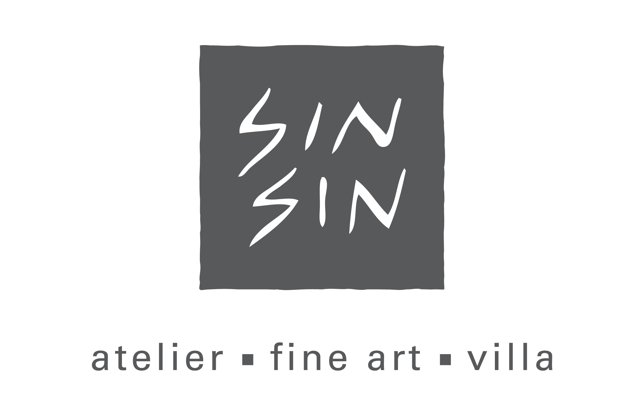
Lee Man Sang
Rick Lewis
Hervé Maury
Pablo Posada Pernikoff
Group Exhibition
Opening Reception: 10 February, 6 – 9 pm
Exhibition Duration: 10 February – 3 March, 2012

Sin Sin Fine Art is pleased to present a group exhibition of the work of celebrated artists Lee Man Sang, Rick Lewis, Hervé Maury and Pablo Posada Pernikoff. The exhibition will feature a broad selection of the artist’s beautiful contemporary art work on different media. Extending the harmonious atmosphere brought from Chinese New Year, the artists will give their personal interpretation on their personal feelings related to nature.

The exhibition will run from February 10th through March 3rd. On Friday, February 10th from 6:00pm to 9:00pm guest can join Lee Man Sang for a discussion of his work and philosophy in our opening night event. It promises to be a remarkable evening of lively conversation as well as a rare opportunity to meet this normally very private artist.

About the artists:
Lee Man Sang is a master craftsman, musician and sculptor. He lives a reclusive life in the rural part of Hong Kong and his art reflects his love of nature and rhythm with strong solitary sentiment. The artwork in this exhibition combines Chinese oil paper and beautiful natural texture of timber wood. Lee’s works have the quality of a sophisticated craft though it is his profound concept and subtlety that distinguish him as an artist from his contemporaries.

Rick Lewis is a New York based painter. For his work, the theme is a story of floods. The way of him working on his canvases is fundamentally a form of carving, of digging into material surfaces. These are objects that are direct expression of makers interested in physicality over ethereality. He depicts historical and fictional events using mixed media. He has won the awards of Millay Colony, Austerlitz, New York and Edward F. Albee Foundation, Montauk, New York. His works had been publicly collected by Bali Purnati Center for the Arts Bail, Indonesia, Brown & O'Toole, New York, United Airlines, Washington Dulles International Airport and Dishman Art Museum, Lamar University, Beaumont, Texas.

New Brush French artist Hervé Maury showcases his series of mix media paintings inspired by natural animals. Hervé works with varies of materials to create rich distinctive texture in a way that is a more subtle and organic palette, the theme of animals still has a special place for Hervé’s artistic practice. In this exhibition, Hervé combines his signature animals with spontaneous writings. The result is refreshing and they have opened up new doors for Hervé’s creative journey. Hervé has exhibited in internationally, including solo exhibitions in Gallery INVISIBLE, Marseille, France (2009). He has also created special collections for the Centre Pompidou’s museum shop. In 2006, his “polar bear” series were featured in display windows of Hermès airport boutiques worldwide.

French-Colombian artist Pablo Posada Pernikoff was born in Spain in 1964, lived and studied in France, Colombia, Canada, Italy, and now lives and works in Tokyo, Japan. Pablo's works are an abstraction based on his observation of the natural phenomenon of matter flowing through space and time, resulting in a harmonic relationship between the works and the viewer through the sense of movement of the highlights and shadows emerging from the lines in metal and paper he use for his work.

For high resolution images and further information please contact:
David Har
Email: david@sinsinfineart.com
Mobile: 92050523
Winkie Chan
E-Mail: winkie@sinsinac.com
Mobile: 9677-8887
Sin Sin Fine Art
53-54 Sai Street, Central, Hong Kong, Tel: (852) 2858 5072
Email: info@sinsinfineart.com | Website: www.sinsin.com.hk
Open Tue-Sat 9:30am-6:30pm. Sun 1:30-6:30pm
Closed Mondays and Public Holidays

____________________________________________________________________________________

