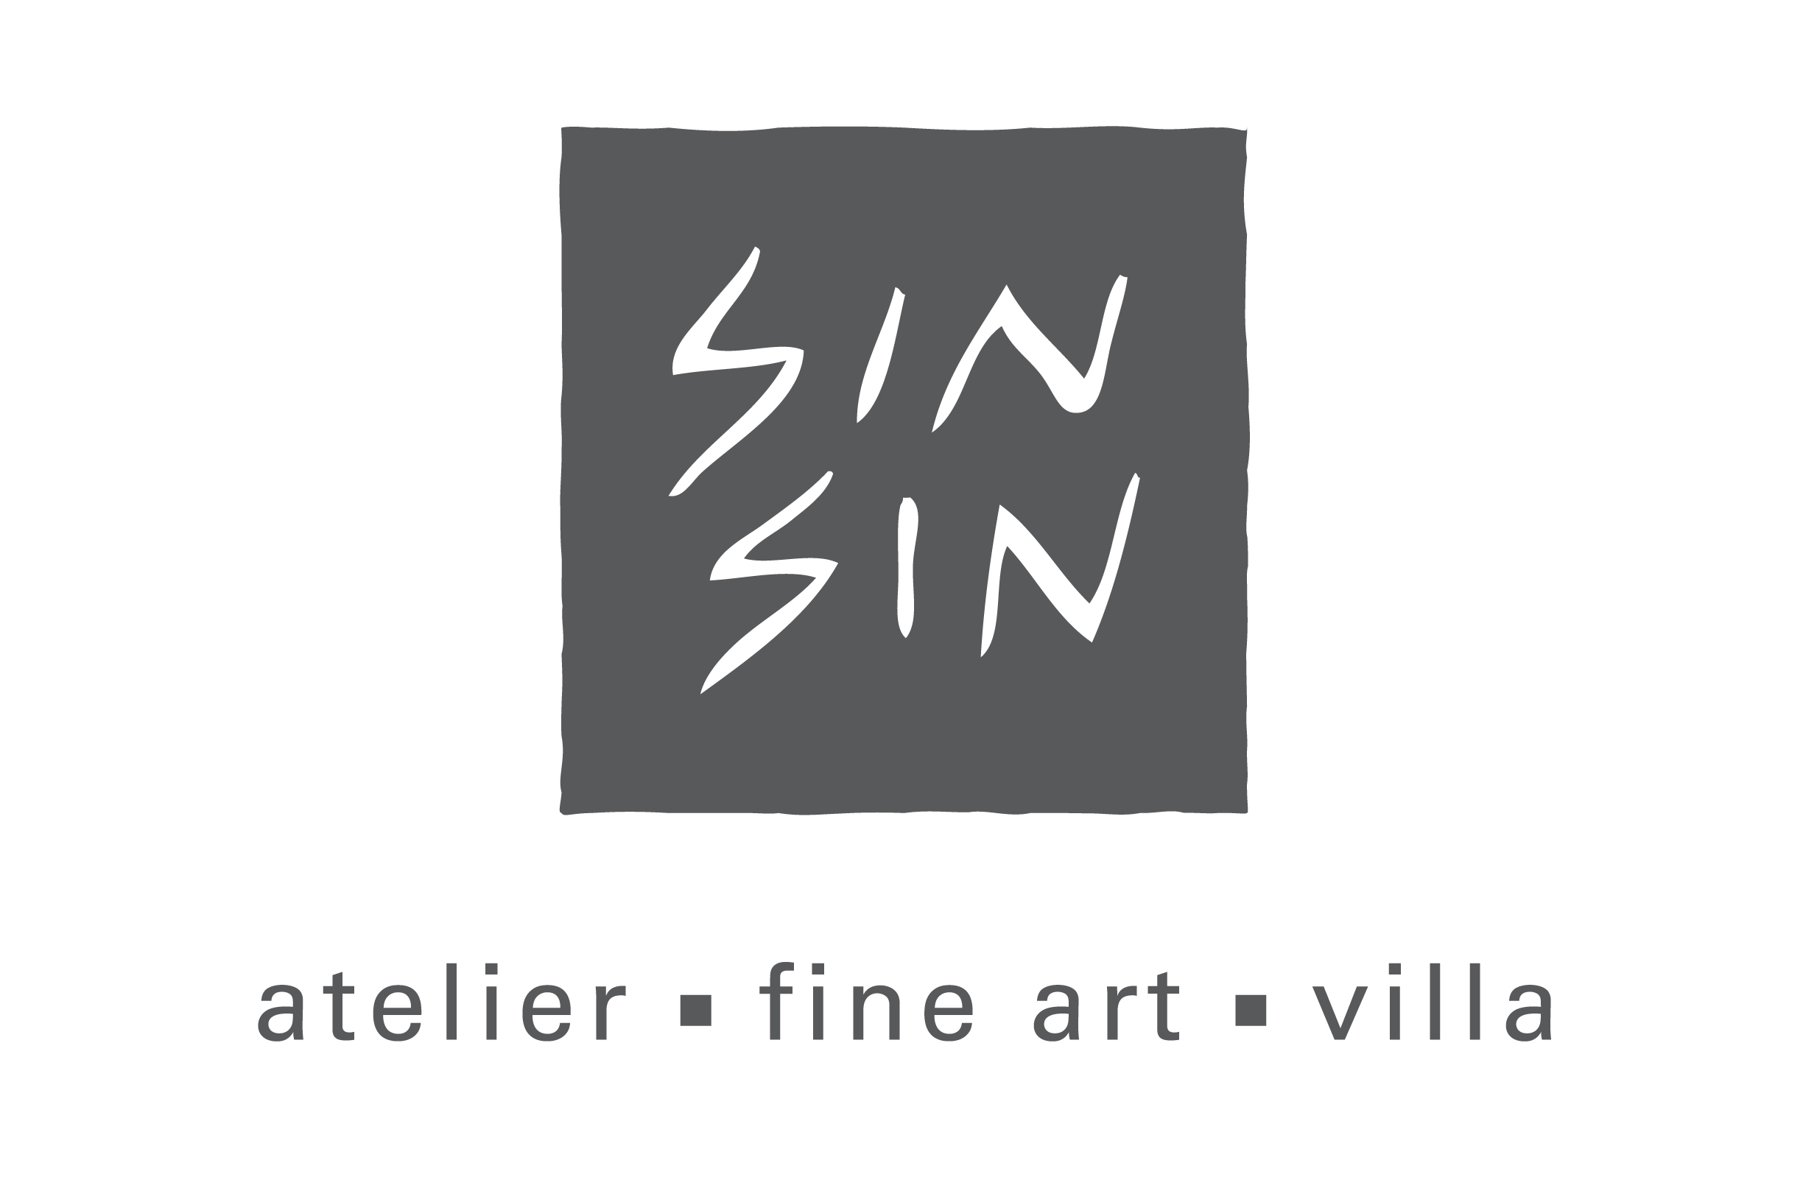
For immediate release December 9, 2011

Reach for the HeART
Fundraising Campaign to Support Art In Hospital
Promoting “Self Healing with Art”

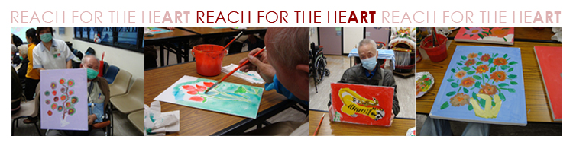

(December 2011, Hong Kong) Sin Sin Fine Art and Art In Hospital were delighted to present its annual charity fundraising campaign for “Reach for the HeART”. “Self Healing with Art” was this year’s theme to promote.

Reach for the HeART programme was initiated by Sin Sin Fine Art in 2009 and run by Art In Hospital, a registered charitable organization in Hong Kong. Sin Sin, Founder of Sin Sin Fine Art gratefully said, “Art In Hospital has been providing free art workshops and other art activities that are specifically designed for elderly patients with chronic diseases in public hospitals so as to re-build the confidence in themselves and passion for life which are the essential elements for them.”

Ms. Grace Cheng, Director of Art In Hospital pointed out and said, “It has been proven that the creative process involved in artistic self-expression helping people to resolve conflicts and problems, reduce stress, increase self esteem and contribute to their overall well-being. Massive positive feedbacks are received from the patients and families which are so encouraging to the continuity of the Reach for the HeART programme. Our aims are to bring joy and light into the lives of the elderly patients.”

Since its inception in 2009, 88 workshops have been conducted in Pamela Youde Nethersole Eastern Hospital, Grantham Hospital, Haven of Hope Hospital and Caritas Medical Centre; and 4 exhibitions had been organized in Pamela Youde Nethersole Eastern Hospital, Queen Elizabeth Hospital, Artist Commune and The Central Oasis respectively, with over 1,000 elderly patients and their families benefiting from the programme. Sin Sin Fine Art and Art in Hospital made their effort to raise sufficient funds in order to offer regular free art workshops in six hospitals in 2012 to benefit more patients.

In the press briefing, various celebrities and artists in town joined in to show their continuous support to Reach for the HeART, namely Ms. Crystal Kwok, Ms. Maggie Shiu, Ms. Stephanie Sin and Mr. Tang Kwok Hin.

In addition to fundraising, public awareness was the focus of the campaign about the meaningful cause via various activities:

Fung Ming Chip Artist Talk
17 November
100% admission fee donated to Reach for the HeART.
Venue: Sin Sin Fine Art, 52-54 Sai Street, Central

Luncheon at the KEE Club
6 December
50% donated to Reach for the HeART.
Venue: 6/F, 32 Wellington Street, Central

Sandra d'Auriol Jewellery Christmas Show
7 - 8 December
20% proceeds donated to Reach for the HeART.
Venue: Sin Sin Fine Art, 52-54 Sai Street, Central

Reach for the HeART Charity Exhibition
9 - 31 December
1/3 of sales donated to Reach for the HeART.
Venue: Sin Sin Fine Art, 52-54 Sai Street, Central
Participating Artists of the Charity Group Exhibition*:
Ann Niu • Damon Tong • Fung Ming Chip • Gavin Au • Hengki Pudjianto • I Gusti Ngurah Buda • Jaffa Lam • Julia Nee Chu • Kokok P. Sancoko • Koon Wai Bong • Lee Man Sang • Mak Sau Ying • Maria Lobo • Rick Lewis • Stephanie Sin • Sun Guangyi • Suzy Cheung • Tang Kwok Hin • Tilo Kaiser • Wong Wing Tong • Wong Yan Kwai •

MCCM Creations book sales
9 - 11 December
15% sales donated to Reach for the HeART.
Venue: Sin Sin Fine Art, 52-54 Sai Street, Central

Greeting card
Blank cards featuring artwork by 5 patients who participated in the Reach for the HeART programme.
$150 per pack of 10 cards with matching envelops.
100% donated to Reach for the HeART.
Venue: Sin Sin Fine Art, 52-54 Sai Street, Central

Christmas Shopping at Sin Sin Atelier
9 December
20% of the sales will be donated to Reach for the HeART.
Venue: Sin Sin Fine Art, 52 Sai Street, Central

For more information, please visit below websites:

Sin Sin Fine Art
www.sinsin.com.hk

Art In Hospital
www.aih.org.hk/aih/Home.html

fine art
53-54 sai street, central, hong kong

atelier
52 sai street, central, hong kong

villa
jalan kuwum 1, banjar kuwum, kerobokan 80361, kuta, bali, indonesia

