VIP Programme for ARTHK11
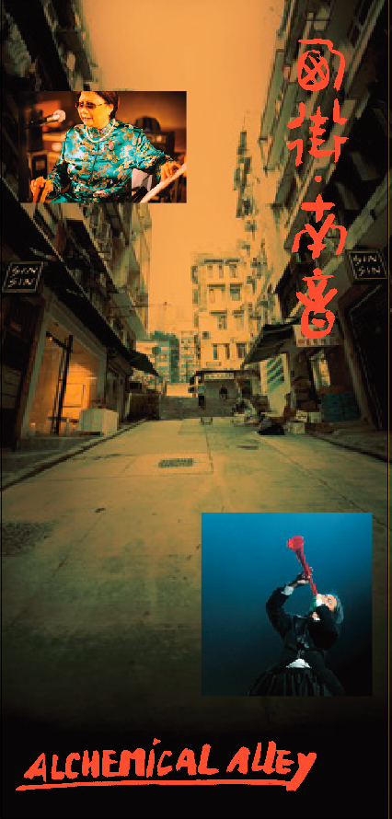
Alchemical Alley (by invitation)

Concept: Kung Chi Shing

Performers: Tong Siu Yin, Nerve, Wilmer Ongsitco Chan, Tso Po Lin, Yvette Huang, Icey Lam

Venue: 52 - 54 Sai Street, Central, Hong Kong

Date: 28 May 2011

Time: 7:30pm – 8:45pm

A cross-media outdoor performance curated by renowned musician Kung Chi Shing, integrating traditional nanyin (the original Chinese ‘street music’) with experimental/electronic music and physical theatre. Alchemical Alley is the performers’ response both to the dynamic energy of Sai Street, where old and new Hong Kong co-exist, and to artist Fung Ming Chip's contemporary calligraphy, exhibited in 3 spaces of Sin Sin Fine Art, in the heart of Sai Street.

Artists’ Bio

Kung Chi Shing

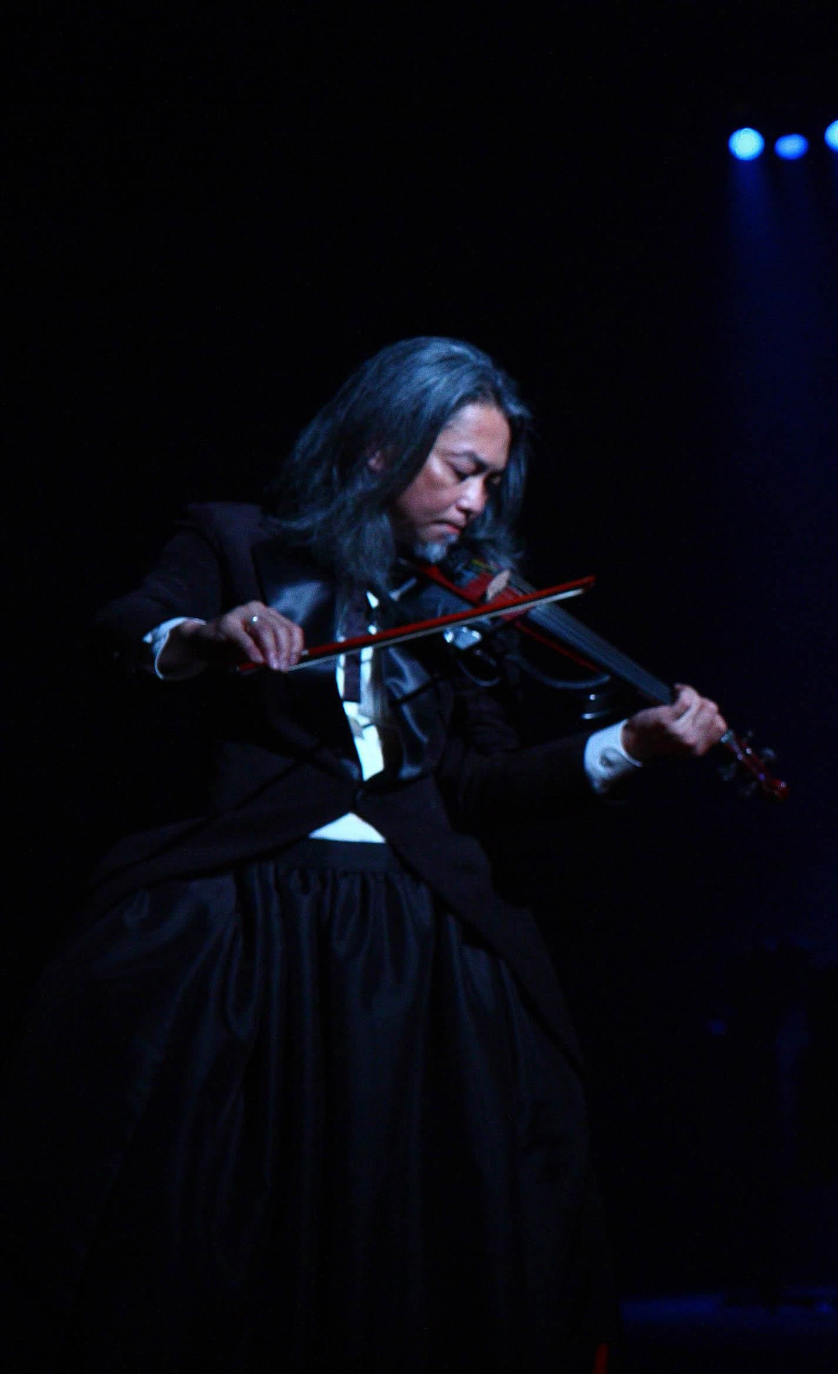

Born and raised in Hong Kong, Kung Chi Shing is a composer, performer and music activist. Kung studied classical music and composition in the United States with Allen Trubitt and George Crumb. He is known particularly for his work in the music and performance group ‘The Box’, which he founded with Peter Suart in 1987, and more recently as founder and curator of the ‘Street Music Series’ of free public concerts in Hong Kong.
Kung’s music/theatre works include City Inside a Broken Sky, M Garden, etc. Kung has also designed two sound installations including 430 hours: a short history of the world and Wavelengths (450-570nm).

Tong Siu-yin

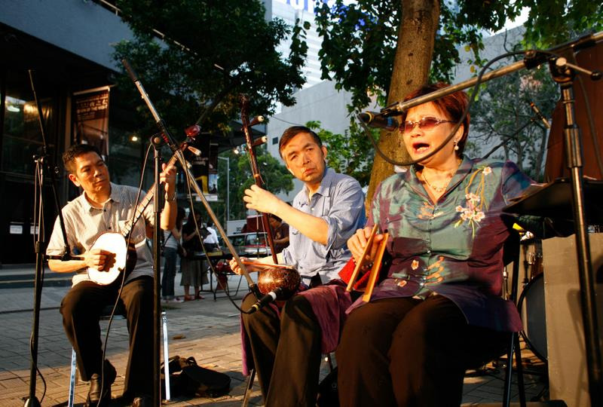

Tong Siu-yin had lost her full vision when she was 18-month-old due to measles. She has been an amateur singer of Cantonese Opera and Pop songs for over 10 years. Playing a part in an independent film, she learnt nanyin few years ago and has fallen in love with this traditional folk music style. She is now the only female nanyin singer in Hong Kong.

Nerve

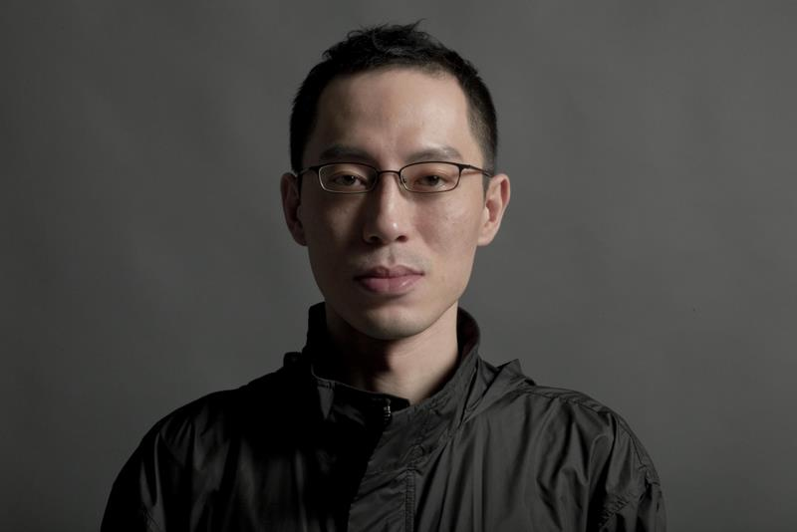

Nerve is an alias of Steve Hui for presenting his music. Hui graduated from the Hong Kong Academy for Performing Arts with a master degree in composition and electronic music. He is a member of experimental electronic music group VSOP and DJ of the clubnights “Headroom” and “Are Friends Electric?”. With his multidisciplinary background, Hui’s main interest lies in exploring and experimenting the boundaries between contemporary music, sound art, multimedia theatre and pop culture. His first orchestral work Re-Autumn was commissioned by the Hong Kong Sinfonietta. In 2006, Hui was invited by the Asia-Europe Foundation for “Hearing Helsinki” project in Finland. His first digital opera The Memory Palace of Matteo Ricci was commissioned by Zuni Icosahedron in 2010.

Wilmer Ongsitco Chan



Wilmer Ongsitco Chan is currently in the process of completing his Bachelor degree in Music Theory/Composition and Studio Art from Lawrence University, WI.
Wilmer’s main interest however lies in the spontaneity and freedom in musical improvisations, and wishes to continue perform and help promote such practice in Asia in the future.

Tso Po Lin

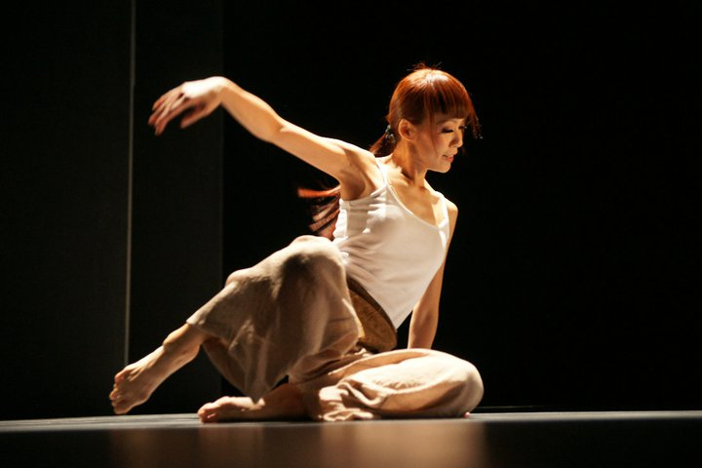

Tso graduated from the School of Chinese Dance of the Hong Kong Academy of Performing Arts.
In 1988 she was awarded a scholarship by ACC and BAT and joined the American Dance and Jacob’s Pillow Dance festivals in the USA. She also gained valuable daily life experience from a residency in New York.
Tso joined the Hong Kong Dance Company in 1989 and undertook major roles.
In 1995 she received another scholarship from The Hong Kong Jockey Club to study in the Alvin Ailey American Dance Centre in New York. Upon her return to Hong Kong she was awarded Artist of the Year 1997—Dance by the Hong Kong Artists’ Guild, and received a 2005 Fellowship Award from Spring-Time Stage Productions. Recently, Tso has debuted her dance theatre work Lotus in Motion in 2010.

Yvette Huang

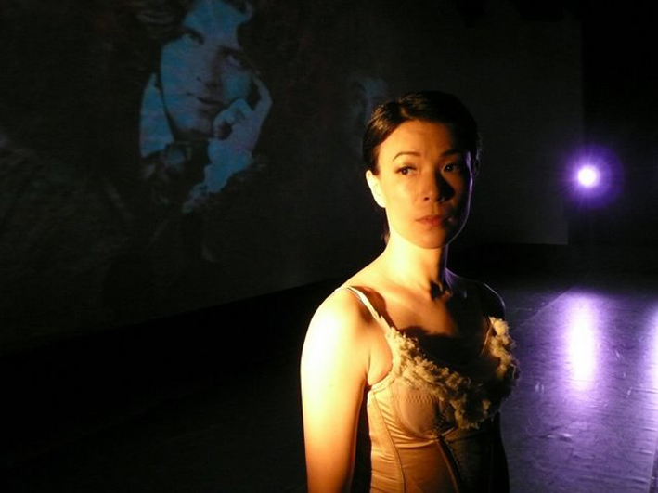

Huang was trained in Chinese dance at the Hong Kong Academy for Performing Arts. Upon graduation, she joined the City Contemporary Dance Company. Huang joined DanceArt Hong Kong as a core member in 1995, and with the group she toured Taiwan, Germany and various cities of the United States. She debuted her work, Remembering at the Asian Contemporary Dance Festival in New York. Huang has been teaching dance at the City Contemporary Dance Company, the Hong Kong Ballet, the outreach programmes organized by DanceArt, and served as dance instructor and choreographer in various schools, spanning primary, secondary and tertiary, in a bid to promote dance. She gave her solo dance showcase, She’s The One – Yvette’ One Show in 2005.

Icey Lam



Lam was trained in Chinese dance at the Hong Kong Academy for Performing Arts, and joined the Hong Kong Dance Company upon leaving the Academy. She is currently a freelance dancer.

