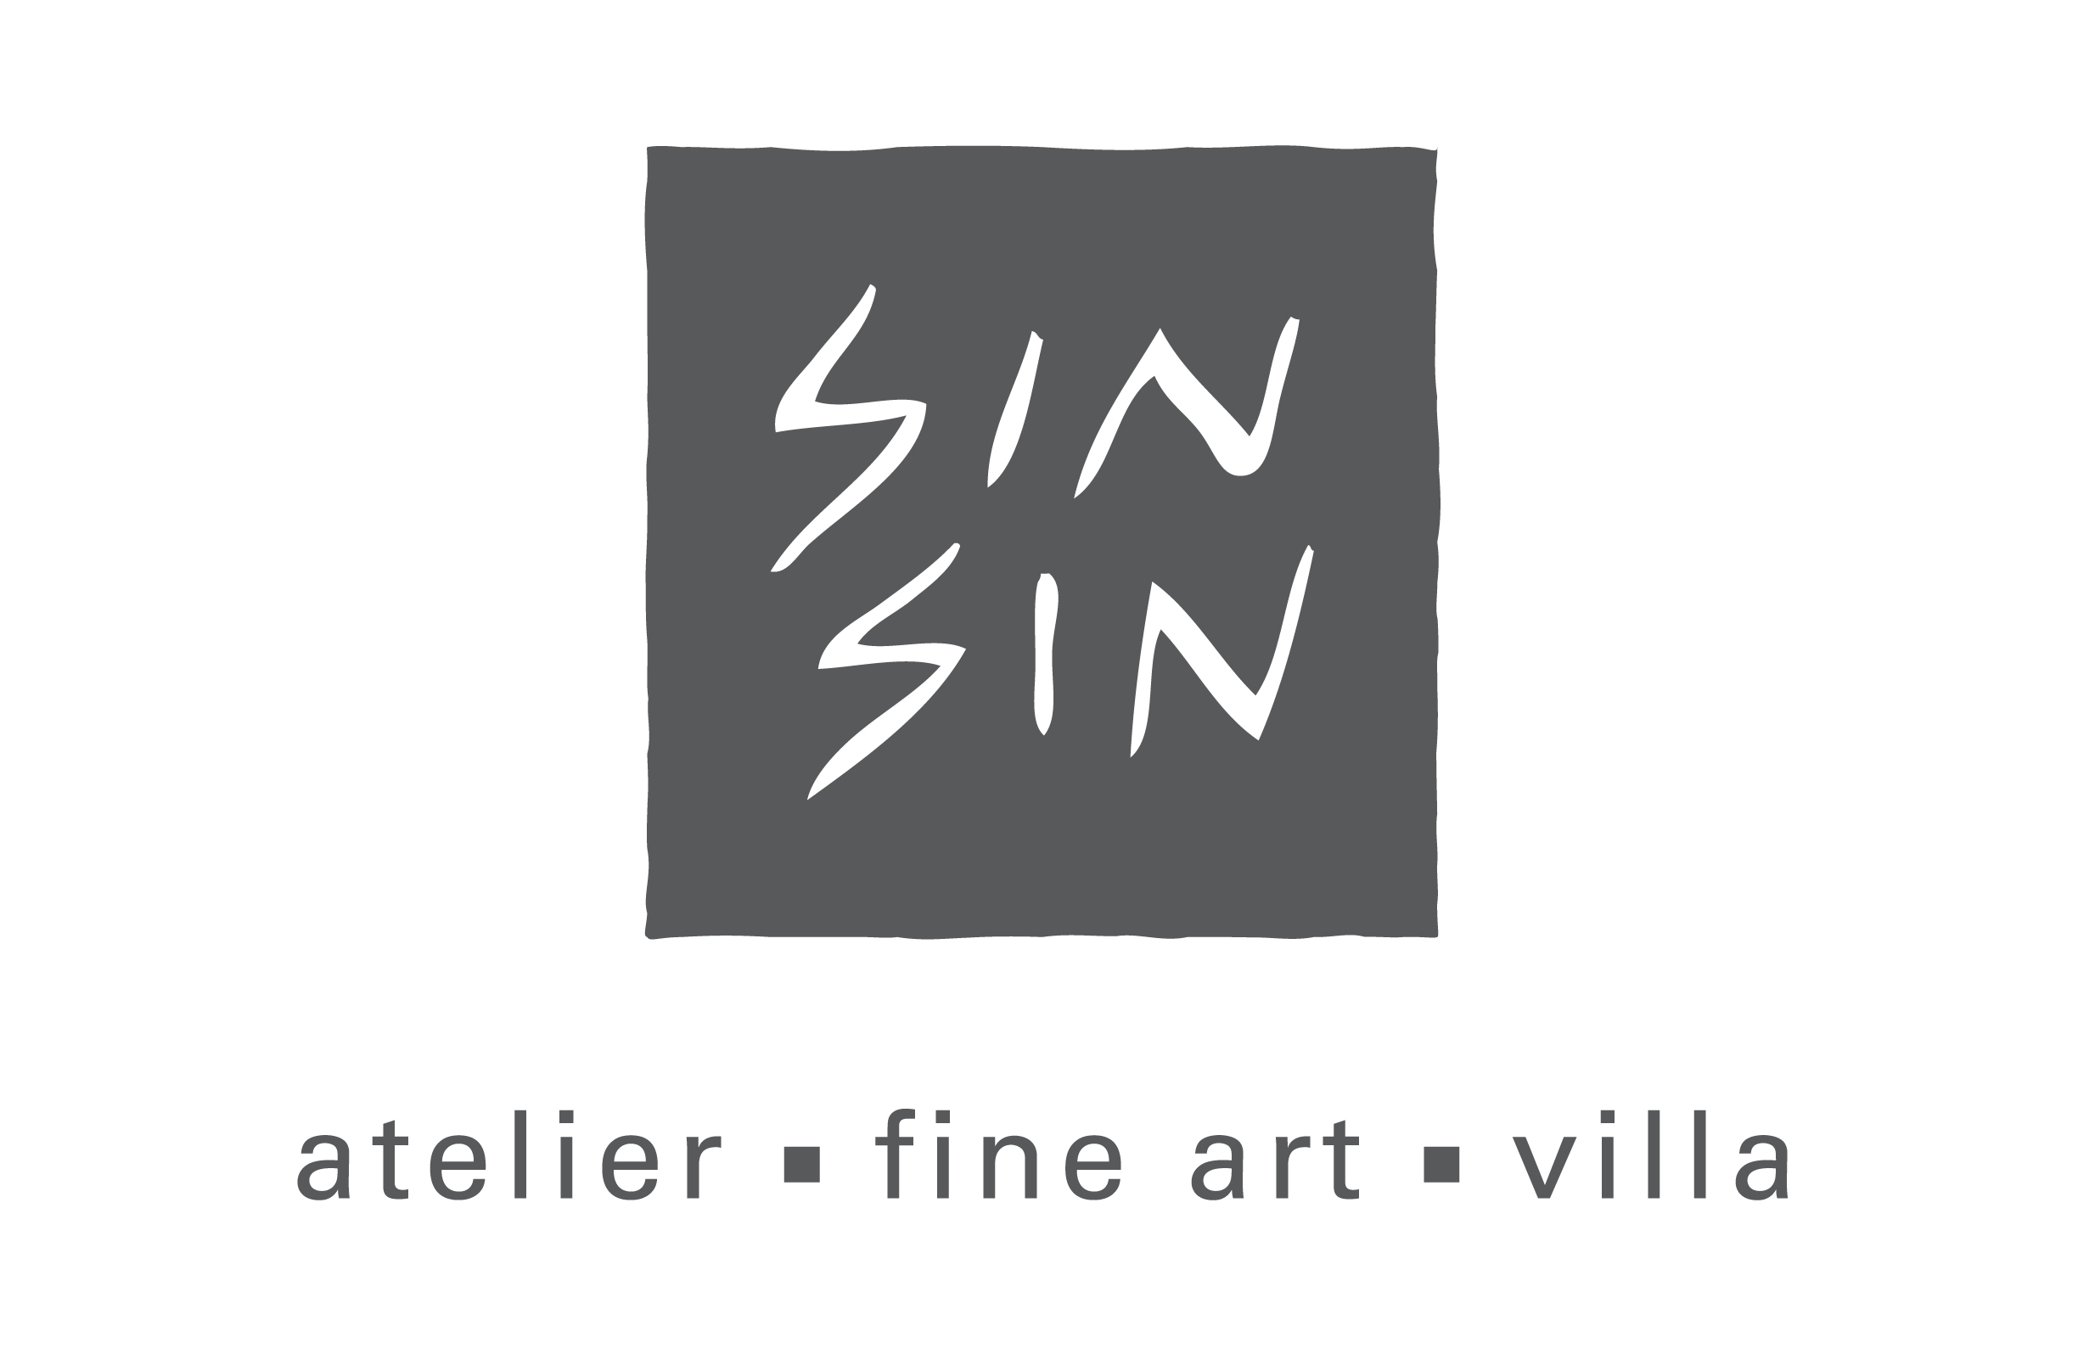

Sin Sin Fine Art is delighted to present "New Brush", a solo exhibition by French artist Hervé Maury, from 8 December 2010 till 8 January 2011. We are very happy to welcome Hervé back again after his successful solo exhibition –“77” with a series of animal paintings shown at our Fine Art gallery in January 2010. In “New Brush”, Hervé will showcase a series of mix media paintings inspired by Asian culture.
During his visit in Hong Kong earlier this year, Hervé was fascinated by the cultural difference between the East and West. Upon his return to France, in tradition of his artistic practice, Hervé continues to work with varies of materials to create rich distinctive texture. Moreover, he has taken up a new challenge by painting with Chinese brushes.
Although moving on to a more subtle and organic palette, the theme of animals still has a special place for Hervé’s artistic practice. In this exhibition, Hervé combines his signature animals with spontaneous writings. The result is refreshing and they have certainly opened up new doors for Hervé’s creative journey.
Hervé was born in Paris, France and currently lives and works in South of France. Hervé has exhibited in internationally, including solo exhibitions in Gallery INVISIBLE, Marseille, France (2009). He has also created special collections for the Centre Pompidou’s museum shop. In 2006, his “polar bear” series were featured in display windows of Hermès airport boutiques worldwide.

