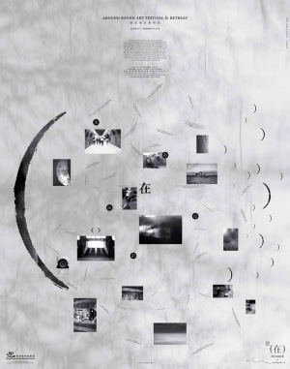

AROUND SOUND ART FESTIVAL AND RETREAT
BY SOUNDPOCKET

MIKI YUI AND ROLF JULIUS
AN OCCASION FOR SLOW AND DEEP LISTENING

EXHIBITION DURATION
20 - 28 AUG, 2010

SIN SIN ANNEX
53 - 54 SAI STREET, CENTRAL, HONG KONG

Around is a three-week original and culturally sensitive sound art event that gathers internationally renowned and Hong Kong’s own sound artists for live performances, installations, and open dialogues. All the works aim at bringing the audience’s attention back to listening itself.

There are music performances and book launch at Sin Sin Annex this year.
Performance
20 Aug (Fri)
7 pm (durational): Rolf Julius – Small Music
8 pm (durational): Miki Yui – Small Sound
On Wide Day
28 Aug (Sat)
3 - 5 pm: Around sound art festival 2009 Book Launch – Meet with writers & artists
Sunset: Miki Yui & Rolf Julius – When small music meets small sound with post-performance sharing

