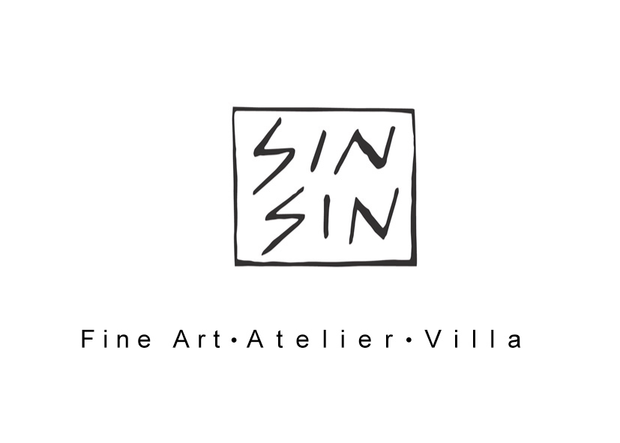

SIN SIN FINE ART PRESENTS

ART SUMMER

Tapas at Sin Sin Fine Art every Saturday July and August

For immediate release

This July and August Sin Sin Fine Art is pleased to present "ART SUMMER" - featuring 21 established and emerging artists from Asia, Europe and North America, include Sovereign Art Foundation finalists, museum and auction house-collected pieces etc. The medium varies from oil or acrylic on canvas and photography.

Explore our treasure trove that spreads over Prince’s Terrace gallery and Annex, with two different group exhibitions in July and August, starting July 7 to August 25, and enjoy artworks by emerging and established artists from the region.

An accompanying catalogue will be published for the exhibition.

The schedules for two group shows are:

July 7-28 August 4-25

Donald Damask, Bai Xincheng,
Entang Wiharso, Eddie Hara,
I Gusti Ngurah Buda, Gerard Bookle,
Jeffrey du Vallier d'Aragon Aranita, Niu Ann,
Julia Nee Chu, Pablo Posada Pernikoff,
Maria Lobo, Putu Sutawijaya,
Rick Lewis, Roland Hagenberg,
Thaiwijit Poengakasemsomboon, Rudi Mantofani,
Youri Leroux, Somyot Hananuntasuk,
Yunizar. Somboon Hormtientong,
Sun Guangyi,

Sin Sin Fine Art Ltd
G/F, 1 Prince's Terrace,
Mid-Levels,
Hong Kong

T: 2858 5072, E: info@sinsinfineart.com, W: www.sinsin.com.hk

Opens Tue-Sat 10:30am-7:30pm, Sun 2:00pm-7:00pm
Closed Mondays and Public Holidays.

