Sin Sin Fine Art proudly presents a solo exhibition

SHADOWS AND LIGHT
by GERARD BOOKLE

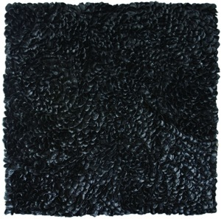

SIN SIN FINE ART
G/F NO. 1, PRINCE'S TERRACE
MID-LEVELS, HONG KONG
11 JAN – 25 JAN 2006

Sin Sin Fine Art wishes to announce the second solo exhibition by Hong Kong based British artist Gerard Bookle, ‘Shadows and Light’. The opening reception will take place on March 15th 2006, from 6pm to 9pmat Sin Sin Fine Art, G/F, 1 Prince’s Terrace, Mid-Levels, and continue through until March 29th, 2006, with works available for viewing throughout the year, by request.

In this recent body of work, Gerard takes a personal perspective on the highs and lows encountered in the cycle of life. In a world filled with contrast and duality, where the negative is often overshadowed, Gerard Bookle attempts to break through the darkness in order to show us that even in death and sadness there is a beauty that should not be forgotten.

Using a diverse range of mediums including glass, metal leaf and mixed media paints on canvas, the artist will showcase his new work from March 15th – March 29th, 2006.

Based in Hong Kong, Gerard Bookle has been active in the local Art scene since 1991. His collaboration with architects and designers has placed his painting, murals, and unique art pieces in various corporate collections such as Swire.

After a very successful debut in 2005, Gerard Bookle’s work is now being sought after by private collectors in Asia, Europe and the U.S and most recently by Cathay Pacific as featured in their first class lounge at London Heathrow Airport.

It is with pleasure that we would like to invite you to attend this special event.

For high resolution images and further information, please contact:
info@sinsinfineart.com
or tel. 2858 5072

