Sin Sin Fine Art proudly presents a solo exhibition

ANGEL IS TERRIFIED
by ANN NEW

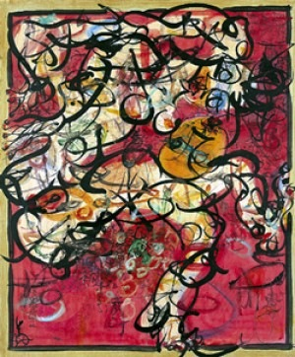

SIN SIN FINE ART
G/F, NO.1 PRINCE'S TERRACE
MID-LEVELS, CENTRAL, HONG KONG
3 JUN – 3 JUL 2004

Hong Kong - June 3, 2004 – Chouinard Gallery HK / Sin Sin Fine Art: Shanghai artist Ann New presents her debut solo exhibition in Hong Kong “Angel is Terrified” on June 3 at Chouinard Gallery HK/Sin Sin Fine Art from 6:30pm-8:30pm where the artist will be present. An artist talk will take place on May 28 at Sin Sin, 18 On Lan Street from 7-8-pm. Artist talk RSVP 2858 5072/ hk@chouinardgallery.com

People are the central idea behind Ann New’s latest series of paintings. Like her previous works, she attempts to convey feelings and emotions that are more unrefined than words. In the “Angel is Terrified” exhibition, Ann New takes away the narrative and brings the viewers closer to the face with the use of a large Chinese calligraphy paintbrush.

Recently, Ann New received a poetry book by German poet Rainer Maria Rilke, entitled Duino Elegies. (Second Elegy) The first sentence of the book reads:
”Every angel is terrifying”. In her own words: “Indeed, perhaps angels do not exist, but we often feel that they are close by. We feel they are just like us. In the busy city, we often think about being fashionable, trying to be cool in the way we act, and imagine that we are as beautiful and as romantic as angels. On the other hand, us “City Angels” are often afraid of solitude, a sense of emptiness, being forgotten, being neglected etc., but this fear is in fact reality.”

Ann New paints with a particular sense of spontaneity. A theme remains constant in her new works, and that is “Soul, Human Nature and Human Relationships”, something she has always been interested in. In this exhibition, she uses a large Chinese calligraphy paintbrush in the “Body” series, forcing the viewers to examine the numerous strong and detailed brushstrokes.

Ann New, having lived, studied and worked in Shanghai, Japan, Korea and America, finds that her diverse experiences influence her individual outlook and in turn her works. This multicultural background, to Ann, befits what it is to be a modern artist. On Shanghai, Ann New’s hometown, she comments:

“I was born in Shanghai. I feel that I understand its nature. Indeed Shanghai means a lot to me now, after having spent many years abroad and re-experiencing the city. I am interested in people…Shanghai is a complex city. It is grand, devilishly beautiful yet novel. At the same time, there is something very melancholic about Shanghai… In the elegance of old Shanghai, there is an adventurous, vibrant and youthful feeling.
In this “Naked” city, it is easy to encounter new relationships and be forgotten by them. Being emotional is what prompts me to paint… I love the dramatic nature in Shanghai. After all – painting is life, and life is drama!”

For high resolution images and further information, please contact:
info@sinsinfineart.com
or tel. 2858 5072

