Sin Sin Fine Art proudly presents a solo exhibition

E V O L U T I O N
by
I GUSTI NGURAH BUDA

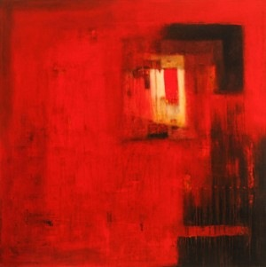

SIN SIN FINE ART
G/F, NO.1 PRINCE'S TERRACE
MID-LEVELS, CENTRAL, HONG KONG
11 DEC 2003 – 31 JAN 2004

Chouinard Gallery Hong Kong, a division of Sin Sin Fine Art Ltd is pleased to present a solo exhibition entitled Evolution by Balinese artist I Gusti Ngurah Buda. The exhibition will run through January 31, 2004.

I Gusti Ngurah Buda’s latest series of abstract paintings juxtapose urban and rural life. The geometric shapes in Buda’s work represent buildings, windows and doors, which overlap more fluid elements, representing nature. This dichotomy symbolizes two sides to Buda’s character. The geometric shapes reflect the artist’s more refined and meticulous character, whereas the flowing elements reflect his sense of freedom and expressive qualities. Like most Balinese, Buda is Hindu and his paintings depict peace and other Hindu sensibilities for nature.

Buda\'s recurrent use of the concrete building imagery reflects his sense and fear of the earth being overpowered by urbanization, where buildings are replacing greenery and traditions are overcome by modernization and shallow modernist philosophy. Born 1975 in Denpasar, Bali, I Gusti Ngurah Buda has held numerous group and solo exhibitions in Hong Kong, Singapore, Indonesia, and the United States. He was the Year 2000 Philip Morris Indonesia Art Award Nominee.

Chouinard Gallery Hong Kong, a division of Sin Sin Fine Art Ltd is located at G/F, 1 Prince’s Terrace, Mid-Levels, Hong Kong.

Open Tuesdays-Saturdays, 10:30am-7:30pm, Sundays 2-7pm,
closed Mondays and Public Holidays.

Tel: 2858 5072
Email: hk@chouinardgallery.com
Website: www.chouinardgallery.com

For further information or photos, please contact Elsie Fung
at 2858 5072 or Elsie@chouinardgallery.com

