Sin Sin Fine Art proudly presents a solo exhibition

THE BEASTS IN ME
by EddiE haRA

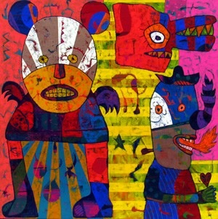

SIN SIN FINE ART
G/F, NO.1 PRINCE'S TERRACE
MID-LEVELS, CENTRAL, HONG KONG
5 NOV – 30 NOV 2003

November 6, 2003 – Chouinard Gallery Hong Kong, a division of Sin Sin Fine Art Ltd., is pleased to present an exhibition of renowned Indonesian born, Switzerland-based artist Eddie Hara, entitled “The Beasts In Me”. An opening reception will be held on November 6, from 6:30pm-8:30pm, and the exhibition will run through November 30, 2003.

Featuring bold and colorful paintings of beasts, cartoon-like figures and animals, the exhibition comprises 18 paintings and 20 drawings from “Postcards from the Alps” series.

The beasts depicted in Eddie’s paintings are angry, humorous, cynical, diabolic and optimistic. These are impressions of the artist having lived in a multi-cultural city like Basel. Portraits of relationships between people and the environment, and inter-human relationships can also be found in Eddie’s works.

In the artist’s own words: “’The Beast In Me’ does not mean that I am a beast as well. Though sometimes I have to be a beast to survive in the city where I live. As an artist I only want to express what I see in my surroundings. At the same time I want to be a ‘good-hearted’ beast, a ‘Sweet Beast’!”

Through Eddie Hara’s paintings, he hopes to inspire his viewers to ponder about the world, issues such as politics, feminism, sexism, wars, poverty, racism etc. His works move one step beyond aesthetics.

Eddie Hara, born 1957 in Salatiga, Java, currently lives and works in Switzerland. Educated in Indonesian Institute of Arts (ISI) Yogyakarta, Indonesia and Akademie voor Beeldende Kunst Enschede (AKI), The Netherlands, Eddie has held numerous solo and group exhibitions in Cuba, France, Germany, India, Indonesia, the Netherlands, and Switzerland.

Eddie Hara’s works are included in the Singapore Art Museum, Museum der Kulturen, Basel, Switzerland, as well as private foundations, corporate and galleries in Indonesia and worldwide.

Chouinard Gallery Hong Kong, a division of Sin Sin Fine Art Ltd., is located on G/F, 1 Prince’s Terrace, Mid-Levels, Hong Kong. Other countries represented include Australia, China, Hong Kong, Japan, Malaysia, New Zealand and Vietnam.

For high resolution images and further information, please contact:
info@sinsinfineart.com
or tel. 2858 5072

